**Final Year Project: DC storage (DAPP)**

**ABSTRACT**

DC Storage is a DAPP (Decentralized Application). It is cloud-like storage where one can access/retrieve, upload data or applications over the internet. Blockchain storage costs can reduce the price of cloud computing. It not only handles storage but also protects and recovers and is transparent to users and also gives high security and privacy to data.

As no central entity or organization can control this so no one can dominate and act as a gatekeeper. Anyone can upload any type of data like docs, images and also one can upload uncensored data because no government or organization can handle it/ control it. Example original news can never be tempered.

So to create DAPP with the help of solidity which is an object-oriented, HLL (High-Level Language) on the Ethereum network for implementing smart contracts. Now Ganache is in the role where it is used to test DAPP in a safe environment means to add a smart contract on blockchain first it will go through ganache. Ganache is a tool used to set up an Ethereum network in this case DC storage is for testing solidity contracts.

To access DC storage through web browsers Reactjs is used, as react will communicate with blockchain through web3js.

Below screenshots are mentioned:

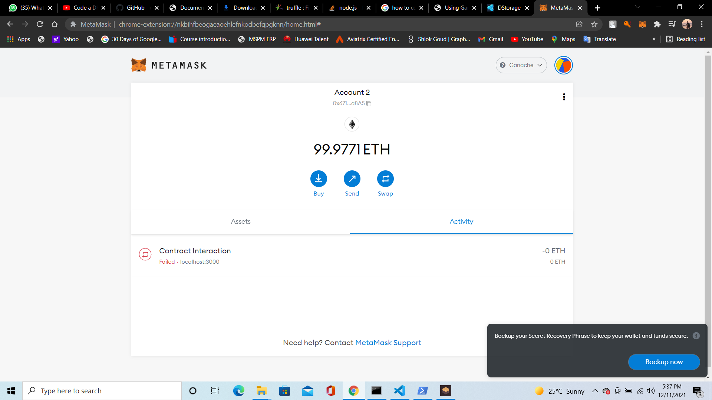

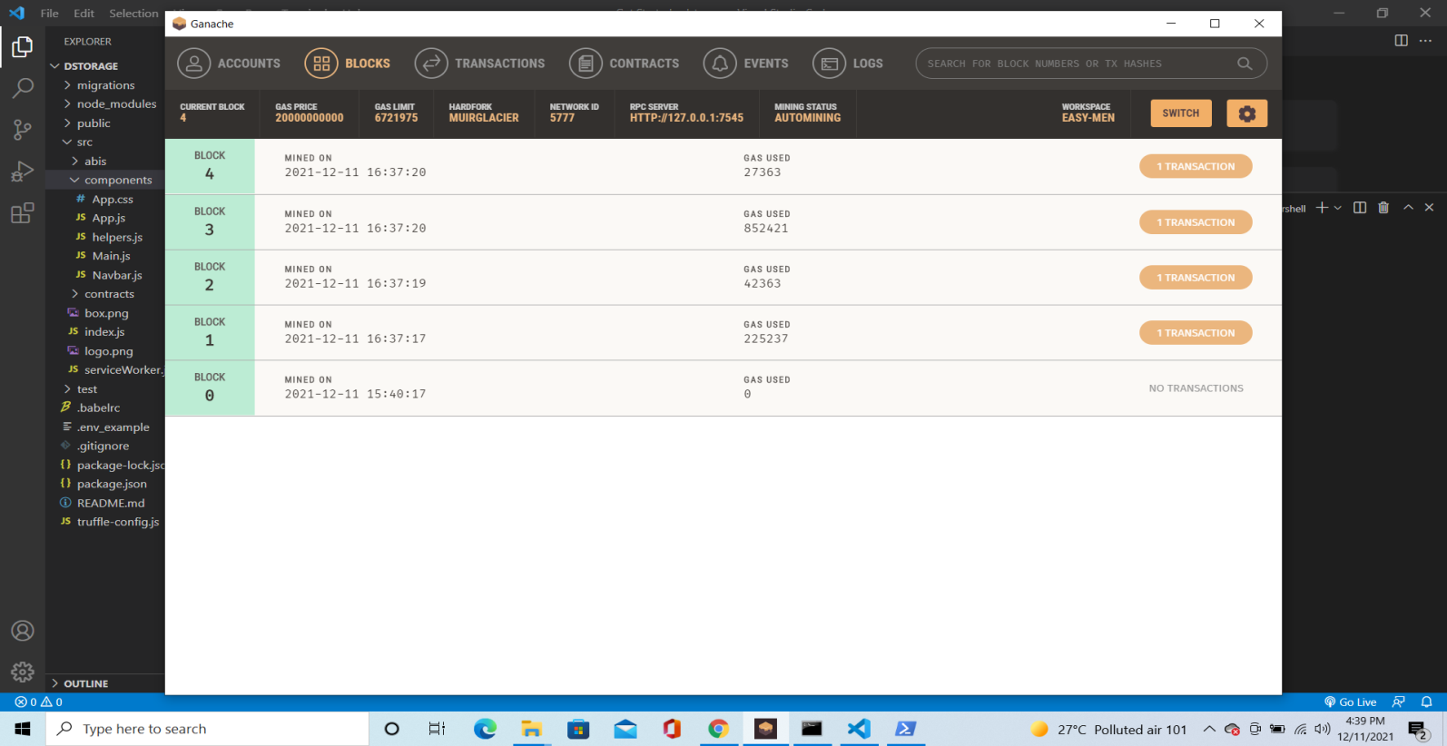

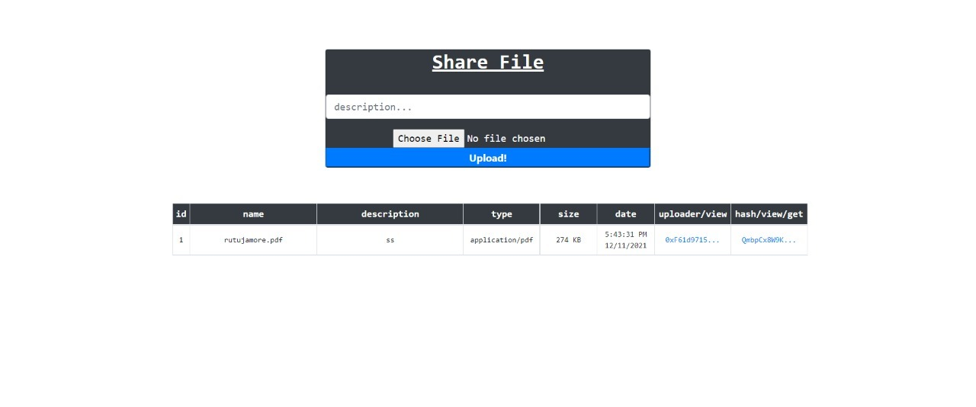

* User Interface is to be created and also in a better presentable way.
* Project completion: 76%